# Lab: PHP Syntax, Basic Web

Problems for exercises and homework for the [“Software Technologies” course @ SoftUni](https://softuni.bg/courses/software-technologies).

You can submit your solutions here <https://judge.softuni.bg/Contests/697/PHP-Basic-Syntax-Lab>.

## Hello, PHP!

### Write PHP script to print "Hello, PHP!"

### Examples

|  |
| --- |
| **Output** |
| Hello, PHP! |

### Hints

You solutin shoud have the following structure:

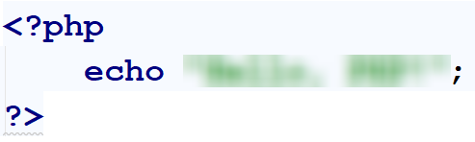

## Numbers 1 to 20

Wrete a PHP script, which prints the **numbers** from **1 to 20** in a list. Every number on **odd** line should be **blue** amd every number on **even** line should be **green**. The list should have the following structure

|  |
| --- |
| <ul>  <li><span style='color:blue'>1</span></li>  <li><span style='color:green'>2</span></li>  <li><span style='color:blue'>3</span></li>  …  </ul> |

### Examples

|  |
| --- |
| **Output** |
| *...* |

## Color Palette

Write a PHP script to print a **color** **palette** like shown below:

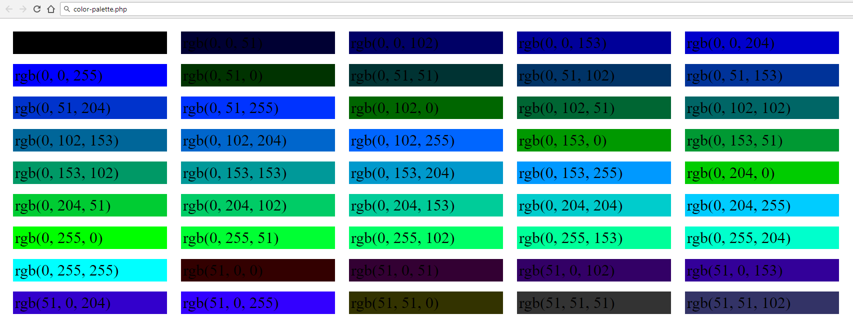

### Hints

* Every <div> should have the following structure:

|  |
| --- |
| <div style='background:rgb(0, 0, 0)'>rgb(0, 0, 0)</div>  <div style='background:rgb(0, 0, 51)'>rgb(0, 0, 51)</div>  …  <div style='background:rgb(0, 0, 255)'>rgb(0, 0, 255)</div>  <div style='background:rgb(0, 51, 0)'>rgb(0, 51, 0)</div> |

* Add the following .css in the <head> section:

|  |
| --- |
| **div {**  **display: inline-block;**  **width: 150px;**  **padding: 2px;**  **margin: 5px;**  **}** |

## Hello, Person!

Write a program which receives a **name** from a **form** and prints in the html the **following** **greeting** (after youy click on the **[Submit]** button). The **form** should **dissapear** after clicking the input.:

* Hello, {name}!

You shoud read the name from the following form:

|  |
| --- |
| <**form**>  Name: <**input type="text" name="person"** />  <**input type="submit"** /> </**form**> |

### Examples



## Dump an HTTP GET Request

Write a PHP script to dump the **content** of the **HTTP GET** request parameters using var_dump(…). Dump the content of the following form:

|  |
| --- |
| <**form**>  <**div**>Name:</**div**>  <**input type="text" name="personName"**/>  <**div**>Age:</**div**>  <**input type="number" name="age"**/>  <**div**>Town:</**div**>  <**select name="townId"**>  <**option value="10"**>Sofia</**option**>  <**option value="20"**>Varna</**option**>  <**option value="30"**>Plodvid</**option**>  </**select**>  <**div**><**input type="submit"**/></**div**> </**form**> |

### Examples

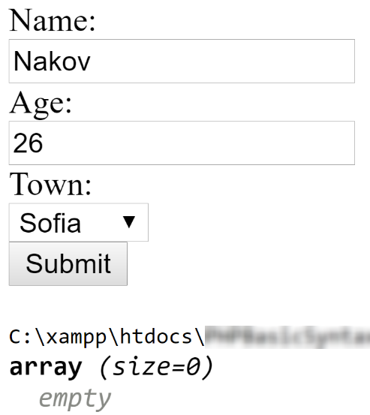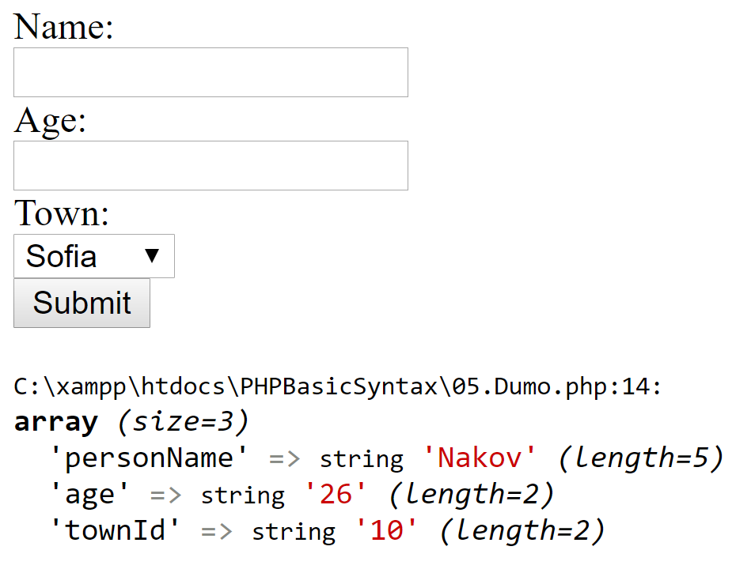

## Sum Two Numbers

Write a PHP script to sum two numbers. The script should display a HTML form to enter the numbers. If the numbers are passed as parameters, display their sum. You wii receive the input from the following form:

|  |
| --- |
| <**form**>  <**div**>First Number:</**div**>  <**input type="number" name="num1"** />  <**div**>Second Number:</**div**>  <**input type="number" name="num2"** />  <**div**><**input type="submit"** /></**div**> </**form**> |

### Examples

### 

## From Celsius to Fahrenheit and Vice Versa

Write a PHP script to convert from Celsius to Fahrenheit (**0 °C = 32 °F**).

* If you convert from Celsius to Fahrenheit print:
  + “{degreesCelsius} °C = {degreesFahrenheit} °F”
* If you convert from Fahrenheit to Celsius print:
  + “{degreesFahrenheit} °F = {degreesCelsius} °C”

The form you should use is the following:

|  |
| --- |
| <**form**>  Celsius: <**input type="text" name="cel"** />  <**input type="submit" value="Convert"**>  **<?=** $msgAfterCelsius **?>** </**form**> <**form**>  Fahrenheit: <**input type="text" name="fah"** />  <**input type="submit" value="Convert"**></**form**> |

### Examples

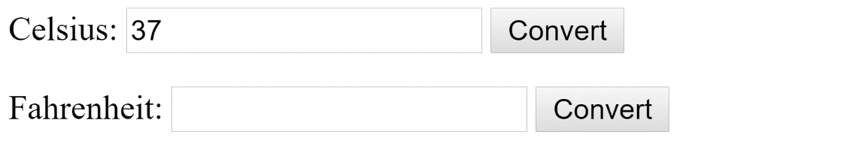

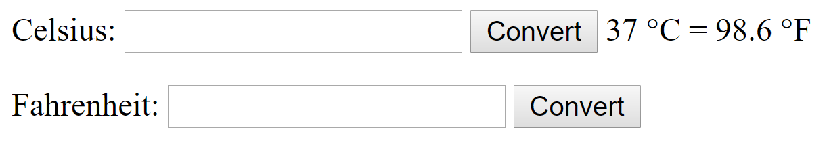

### Hints

* Use &deg; for the degrees sign - °

## Sort Lines

Write a PHP script that **sorts** the **text** lines from a <textarea>. Take the input from the following form:

|  |
| --- |
| <**form**>  <**textarea rows="10" name="lines"**>**<?=** $sortedLines  **?>**</**textarea**> <**br**>  <**input type="submit" value="Sort"**> </**form**> |

### Examples

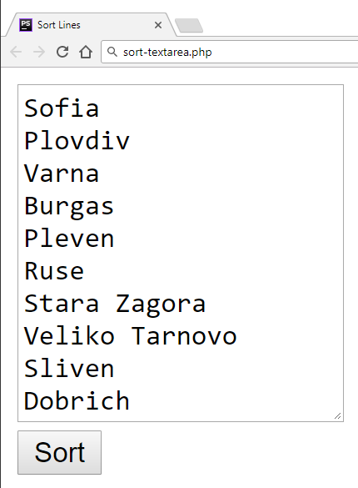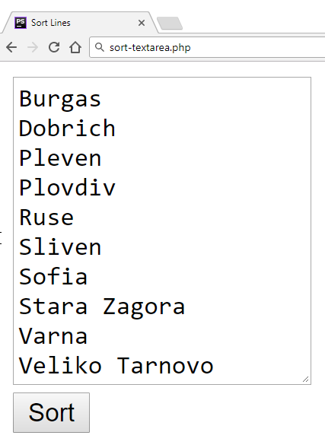

## Extract Capital-Case Words

Write a **PHP** script to extract all **capital-case** words from an **array** of **strings**. All **non-letter** chars are considered **separators**. Use the following form:

|  |
| --- |
| <**form**>  <**textarea rows="10" name="text"**>**textarea**> <**br**>  <**input type="submit" value="Extract"**> </**form**> |

### Examples

|  |  |
| --- | --- |
| **Input** | **Output** |
| We start by HTML, CSS, JavaScript, JSON and REST.  Later we touch some PHP, MySQL and SQL.  Later we play with C#, EF, SQL Server and ASP.NET MVC.  Finally, we touch some Java, Hibernate and Spring.MVC. | HTML, CSS, JSON, REST, PHP, SQL, C, EF, SQL, ASP, NET, MVC, MVC |